I hope you are having a great week so far. Here we again require your assistance in filling the Permanent Sonographers Role in multiple locations.

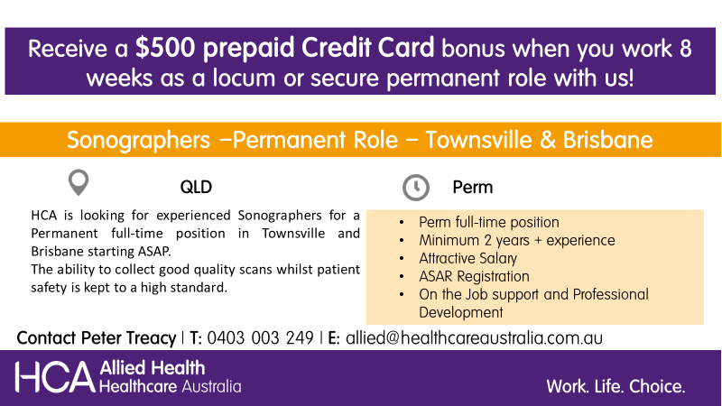

If the role sounds interesting and matching your preferences, please send us your updated resume to allied@healthcareaustralia.com.au or contact Peter Treacy on 0403 003 249.

